**EXPERIMENT-1:**

1)Write code for a simple user registration form for an event.

**Code :**

<!DOCTYPE html>

<html>

<head>

<title>Registration Form</title>

<link type="stylesheet" href="styles.css">

<style>

body{

background-color: red;

}

.bg{

background-color: green;

}

</style>

</head>

<body>

<center class="bg">

<h1>Registration page</h1>

<form action="registration" method="GET">

<label>First Name</label>

<input type="text" name="fname"><br>

<label>Last Name</label>

<input type="text" name="Lname" placeholder="Enter Your name"><br>

<label>Date Of Birth</label>

<input type="date" name="dob"><br>

<label>Email</label>

<input type="email" name="email"><br>

<label>Gender</label>

<input type="radio" name="Gender">Male </input>

<input type="radio" name="Gender">Female </input><br>

<label>Phone No</label>

<input type="number" name="phno"><br>

<label>Address</label>

<input type="textarea" rows=5 cols=5 name="addr"><br>

<input type="checkbox">Accept terms and conditions

<br>

<label>Branch</label>

<select name="ops">

<option value=05>CSE</option>

<option value=66>CSM</option>

<option value=02>EEE</option>

<option value=04>ECE</option>

</select><br>

<button type="submit">Submit</button>

<button type="reset">Reset</button>

</form>

</center>

</body>

</html>

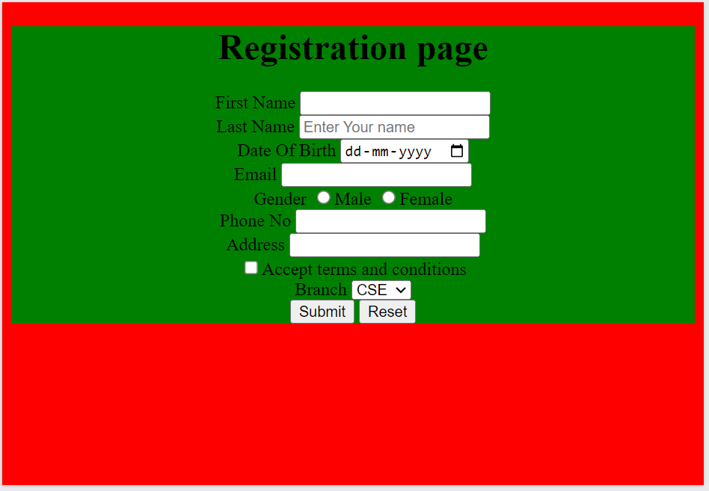**Output :**